Item Governance & Risk Control

From Master Data Configuration to System-Wide Financial Impact

Control Frameworks, Risk Prevention & ERP Integrity
Understanding the Governance Architecture of NetSuite
Weekly Learning Series – Week 10

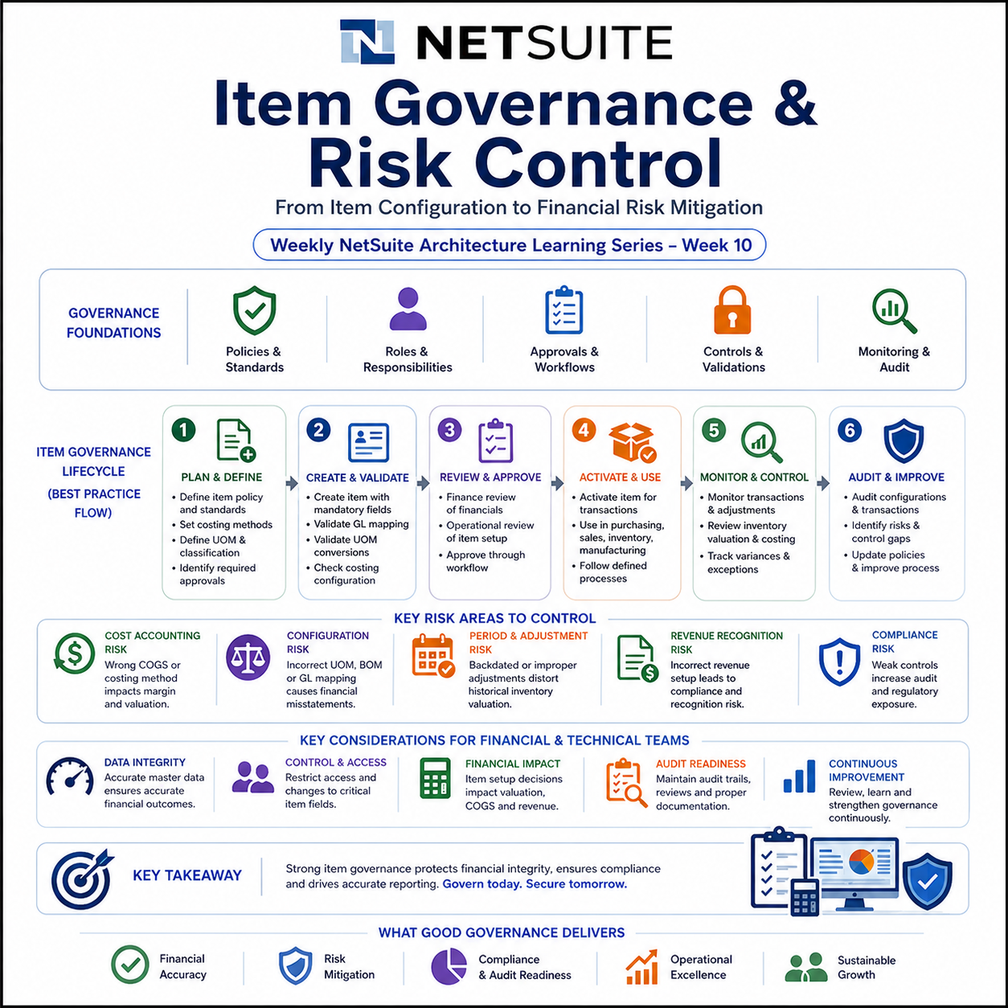

1. Introduction
- Items in NetSuite are not just operational records used for buying and selling goods.
- They are deeply integrated with financial processes such as inventory valuation, cost accounting, revenue recognition, and profitability analysis.
- Because of this tight coupling between operations and finance, incorrect Item configuration can lead to significant financial misstatements, compliance risks, and reporting inaccuracies.
- Item Governance refers to the structured framework of controls, validations, and ownership rules that ensure Items are created, maintained, and used correctly across the system.
- It is a critical layer in NetSuite architecture that protects financial integrity while supporting operational efficiency.

2. Why Item Governance is Critical

2.1 Item Type Governance (Foundation of Financial Behavior)
- Items in NetSuite are categorized into different Item Types, and each type directly determines how transactions behave financially and operationally.
- Common Item Types include:
- Inventory Item
- Non-Inventory Item
- Service Item
- Assembly Item
- Kit/Package
Each Item Type impacts:
- General Ledger Posting Behavior
  - Inventory Items post to asset and COGS accounts
  - Service/Non-inventory items may directly impact expense or revenue accounts
- Inventory Tracking
  - Only Inventory and Assembly items affect stock levels
  - Non-inventory items do not maintain quantity tracking
- Costing and Valuation
  - Inventory items use costing methods (FIFO, Average, Standard)
  - Service items typically do not carry inventory cost
- Revenue Recognition
  - Depends on item type and associated revenue recognition configuration

- Incorrect Item Type selection can lead to:
- Incorrect financial postings
- Missing inventory tracking
- Revenue recognition errors
- Therefore, Item Type selection must be governed as a critical design decision, not just a data entry choice.

2.2 Feature Dependency Consideration
- Item behaviour in NetSuite is influenced by enabled features and modules, including:
- Advanced Inventory Management
- Multi-Location Inventory
- Advanced Revenue Management (ARM)
- Work Orders & Assemblies
- These features alter how Items behave in terms of:
- Costing and valuation
- Inventory tracking
- Revenue recognition
- Transaction processing
- As a result, governance controls must be designed with awareness of enabled system features, as the same Item configuration may behave differently across environments.

3. Governance & Risk Matrix

3.1 Financial Risks (Risks impacting valuation, revenue, and accounting)
- Financial risks arise when Item configuration directly affects accounting outcomes such as inventory valuation, cost of goods sold (COGS), and revenue recognition.
- Since Items determine how transactions post to the General Ledger, any misconfiguration can lead to inaccurate financial statements and misrepresented profitability.
- These risks typically impact:
- Inventory valuation (FIFO, Average, Standard Costing)
- COGS and margin calculations
- Revenue recognition and compliance
- If not controlled, financial risks can result in audit issues, compliance violations, and incorrect business decisions based on unreliable financial data.

3.2 Configuration Risks (Risks arising from incorrect setup)
- Configuration risks originate from incorrect or incomplete Item setup within the system.
- These include errors in Units of Measure (UOM), GL account mappings, costing methods, or Bill of Materials (BOM) structures.
- Such risks are often introduced during:
- Item creation
- Master data updates
- System configuration changes
- Configuration errors may not immediately surface but can propagate across multiple transactions, leading to systemic data inconsistencies and financial inaccuracies over time.

3.3 Operational Risks (Risks from process failures and user actions)
- Operational risks arise from improper usage of Items during day-to-day business processes.
- These include user errors, lack of process controls, and unauthorized or backdated transactions.
- Common sources include:
- Manual inventory adjustments
- Backdated transactions in open periods
- Lack of approval workflows
- Inadequate user training or access control
- Operational risks can distort historical data, impact reporting accuracy, and reduce trust in the system if not managed through strong governance and process discipline.

3.4 Risk Analysis Table
Risk | Root Cause | Financial Impact | Control Mechanism
Incorrect COGS Mapping | Misconfigured COGS account in Item record | Distorted gross margin and profitability | Finance review of GL mappings before item activation
Costing Method Change Mid-Year | Change in costing policy after transactions exist | Inventory valuation inconsistency | Restrict costing method changes post-transaction
Unit of Measure (UOM) Error | Incorrect conversion ratios | Over/undervaluation of inventory | Mandatory UOM validation
Bill of Materials (BOM) Error | Incorrect structure or quantities | Incorrect assembly cost | Formal BOM approval workflow
Backdated Inventory Adjustments | Weak period control | Distorted historical inventory valuation | Accounting period locking
Deferred Revenue Configuration Error | Incorrect revenue setup | Revenue recognition compliance issues | Periodic revenue audits
- This matrix highlights how Item misconfigurations are not isolated issues but systemic risks affecting financial accuracy.

4. Core Governance Principles
- Effective Item governance requires cross-functional coordination, primarily between Finance, Operations, and IT.

4.1 Ownership & Responsibility
- Finance owns:
  - GL account mappings
  - Costing methods
  - Revenue recognition configuration
- Operations owns:
  - Item usage and classification
  - BOM and manufacturing structure
- IT/NetSuite team owns:
  - System validations and workflows

4.2 Controlled Item Creation
- Items should not be freely created by all users
- Use approval workflows before activation
- Enforce mandatory fields and validations

4.3 Standardization
- Use predefined templates for Item types
- Enforce naming conventions
- Maintain consistent UOM structures

4.4 Period Control
- Lock accounting periods to prevent backdated changes
- Restrict inventory adjustments in closed periods

4.5 Continuous Monitoring
- Review inventory valuation reports regularly
- Track variance accounts (especially in Standard Costing)
- Audit item configuration periodically

5. Control Implementation Strategies
- Governance is useless if it only lives in documentation. It needs to be enforced through system configuration and process discipline.

5.1 System-Based Controls
- Enable approval workflows for:
  - Item creation
  - BOM updates
- Configure field-level validations
- Use role-based access control (RBAC)
- Restrict editing of critical fields:
  - Costing method
  - GL accounts
  - UOM

5.2 Process-Based Controls
- Periodic review of:
  - Item master data
  - Inventory valuation
- Finance sign-off before:
  - Item activation
  - Costing updates
- Maintain change logs and audit trails

5.3 Preventive vs Detective Controls
- Preventive:
  - Validation rules
  - Approval workflows
- Detective:
  - Reports
  - Audits
  - Exception tracking
- A strong governance framework uses both, because humans are... predictable.

5.4 Automation & Script Governance Risk
- Automation in NetSuite (SuiteScript, Workflows, Integrations) can bypass standard UI validations and introduce significant financial risk if not properly controlled.
- Key risks include:
- Scripts bypassing mandatory field validations
- Direct record updates without approval workflows
- Integrations inserting incorrect or incomplete data
- Automated backdated transactions affecting financial periods
- Control mechanisms should include:
- Enforcing validation logic within scripts
- Restricting script execution roles and permissions
- Logging and monitoring automated transactions
- Aligning automation logic with financial control policies
- Automation must be treated as an extension of the governance framework, not separate from it.

5.5 Audit Trail & System Notes
- NetSuite provides auditability through System Notes and record-level tracking, which capture:
- Field-level changes
- User activity
- Date and time of modifications
- These audit trails are critical for:
- Financial compliance
- Internal audits
- Troubleshooting configuration issues
- Governance frameworks should ensure:
- System Notes are enabled and reviewed periodically
- Critical changes are logged and monitored
- Audit reports are included in regular review cycles
- Strong auditability ensures transparency and accountability across Item lifecycle management.

6. Architectural Perspective
- From an architectural standpoint, Item governance is not just a functional concern. It is a financial control layer embedded within the ERP system.
- Items act as the bridge between:
- Operational transactions (Purchasing, Sales, Manufacturing)
- Financial outcomes (GL impact, valuation, revenue)
- Because of this:
- A single misconfigured Item can affect multiple modules
- Errors propagate across transactions and reports
- Fixing issues retroactively is expensive and complex
- Therefore, governance must be designed as part of the system architecture, not added later as a patch.

6.1 Data Flow & Control Points
- From an architectural perspective, Items participate in a structured data flow:
Item Master → Transaction Processing → GL Impact → Financial Reporting
- Control points exist at each stage:
- Item Master Level
  - Configuration validation
  - Approval workflows
- Transaction Level
  - Field validations
  - Role-based restrictions
- Accounting Level
  - GL mapping enforcement
  - Period controls
- Reporting Level
  - Reconciliation checks
  - Variance analysis
- Designing governance controls at each layer ensures that errors are prevented early and do not propagate across the system.

7. Real-World Risk Scenarios

Scenario 1: Incorrect COGS Account
- A newly created Item is mapped to the wrong COGS account.
- Result: Profit margins appear inflated in reports.
- Impact: Misleading financial decisions.

Scenario 2: UOM Misconfiguration
- Purchase unit = Box (10 units), but incorrectly set as 1:1.
- Result: Inventory overstated by 10x.
- Impact: Financial statements become unreliable.

Scenario 3: Backdated Adjustment
- Inventory adjustment posted in a closed period.
- Result: Historical inventory valuation changes.
- Impact: Audit issues and compliance risks.

8. Best Practices
- Enforce Item Type selection based on defined business rules to prevent incorrect financial behaviour.
- Lock costing methods once transactions exist to maintain valuation consistency
- Validate UOM conversions during Item creation to avoid quantity distortion
- Implement approval workflows for Item creation and modification
- Restrict access to financial fields such as GL accounts and costing configurations
- Align all automation (scripts, workflows, integrations) with governance controls
- Regularly audit Item configurations and financial mappings
- Treat Item master data as financial master data, not just operational data

9. Summary
- Item Governance & Risk Control is a foundational layer in NetSuite that ensures financial accuracy and operational consistency.
- Key takeaways:
- Items directly impact financial reporting, making governance essential
- Misconfigurations can lead to significant financial and compliance risks
- A structured governance framework includes:
  - Risk identification
  - Control mechanisms
  - Ownership definition
- Effective governance combines:
  - System controls (workflows, validations)
  - Process controls (reviews, audits)
- From an architectural perspective, Item governance is a financial control system embedded within ERP design

